

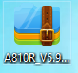1、Unzip the file, correct upgrade file name is suffixed with **“web”**

2、Enter our web interface，**192.168.0.1**



3、Login，the username and password are **admin**

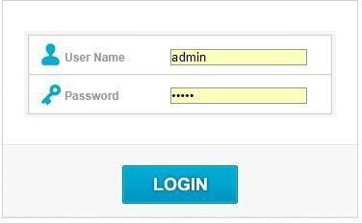

4、Upgrade transition version: **V5.9c.4050_B20190424_transition_ALL.**

Management->upgrade firmware, check ②, click ③, pop up a Window, ④Please

select the correct file, ⑤click "Open”, ⑥finally click "Upgrade". Then wait a few minutes, then the router automatically restarts.

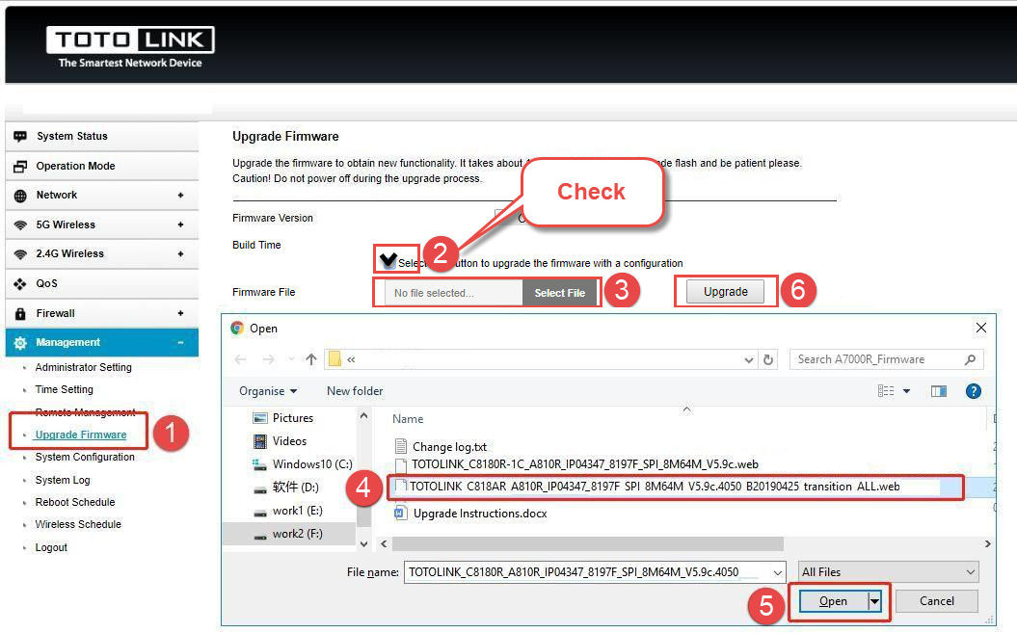

[ Notice ]

DO NOT power off the device or close the browser window during the upload because it may crash the system.

5、Upgrade stable version: **V5.9c.3975_B20190321_ALL**

Log in to the new router page and upgrade the firmware again. Then wait a few minutes, then the router automatically restarts.

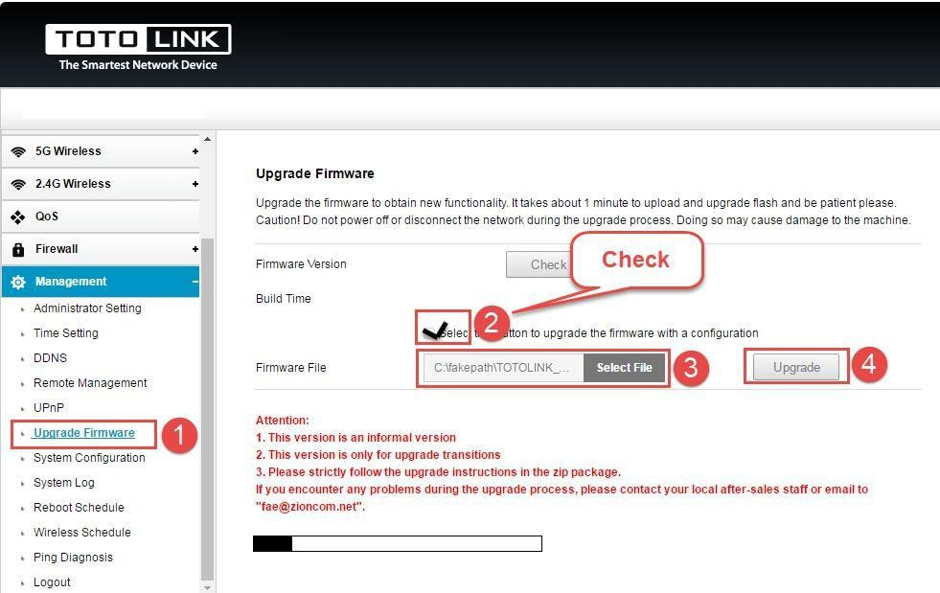

[ Notice ]

DO NOT power off the device or close the browser window during the upload because it may crash the system.

6、After the upgrade is successful, **must be reset the router**.

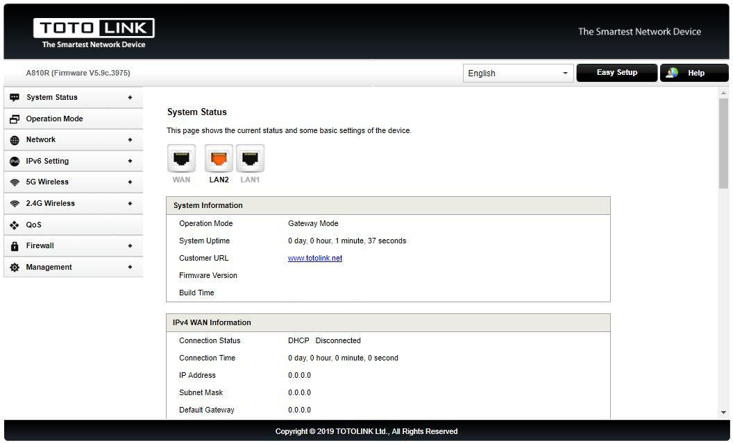

[Attention ]

1. V5.9c.4050_B20190424_transition_ALL is an informal version, only for upgrade transitions.
2. Please strictly follow the upgrade instructions in the zip package.

If you encounter any problems during the upgrade process, please contact your local after-sales staff or email to "[fae@zioncom.net](mailto:fae@zioncom.net)".



**Q1：After entering the management address of the router in the address bar of Chrome browser, the page cannot be displayed after entering the management password. New firmware has been resolved "Chrome issue". Before upgrading the new firmware, you can log in by referring to the following methods.**

**1. Change browser and clear browser cache：**

Try other browser, such as Firefox, Opera, etc., and clear your browser cache.



**Q2：After the upgrade is successful, you cannot log in to the router page, which may be related to factors such as routers and browsers. Please reset the router and clean up the browser cache.**

**1. Reset router：**

Please make sure your router’s power is on regularly, then press the RST button for about 5~8s. Loosen the button until your router’s LED lights all flashing, then you have reset your router to default settings.

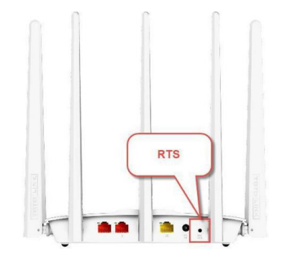**2. Clear your browser cache：**

Delete cookies on the web browser. Here we take Firefox browser for example.

Note: In general, the browser enters the management address of the router and the page display is incomplete. Please use this method first**.**

